CS 255 System Design Document

UML Diagrams

UML Use Case Diagram
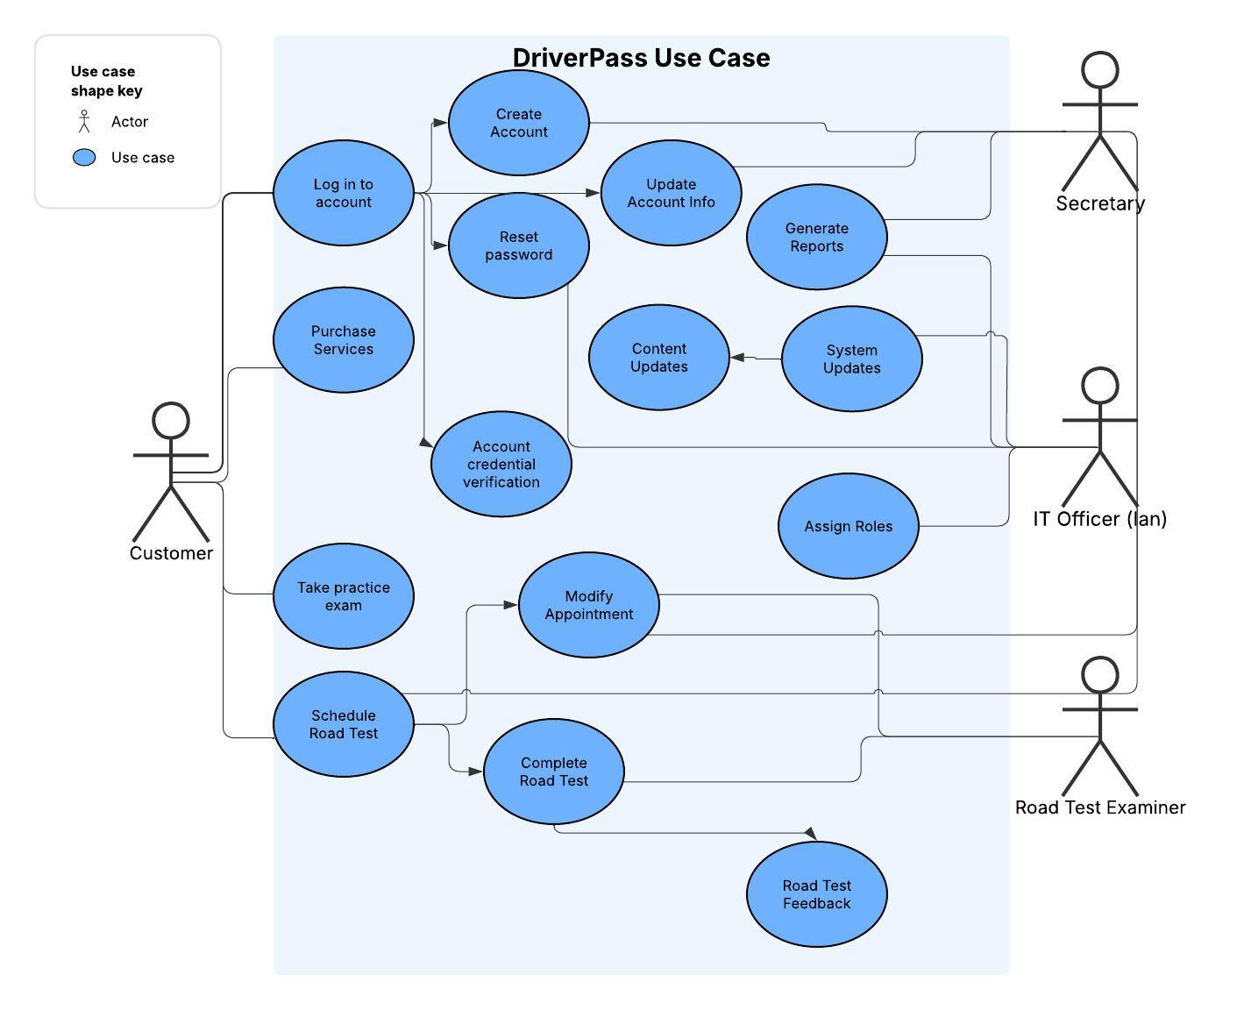

UML Activity Diagrams
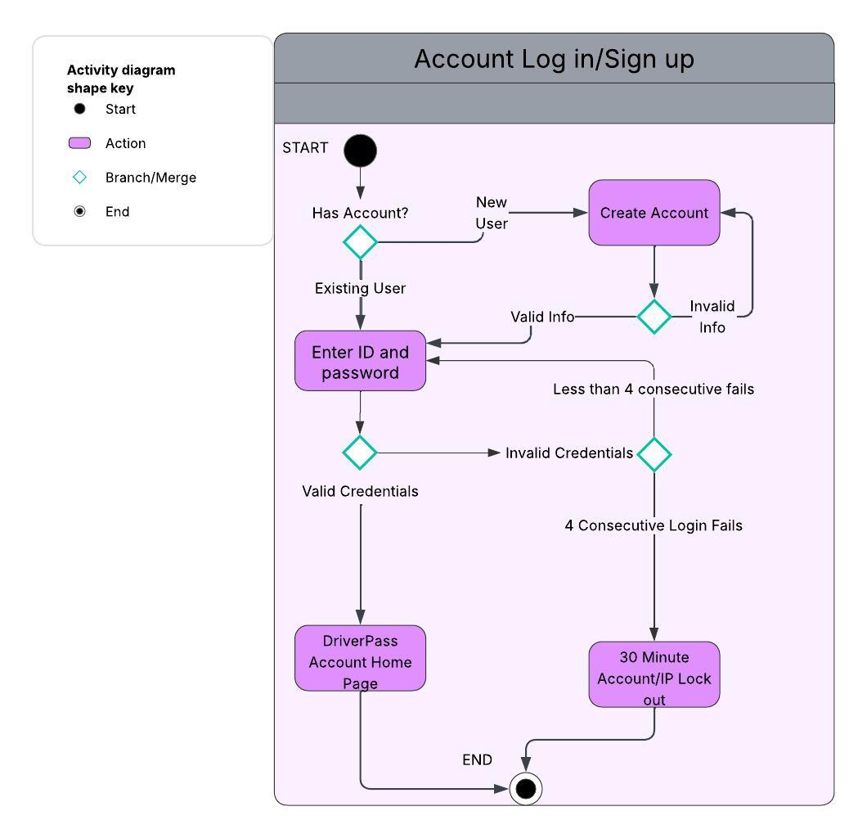
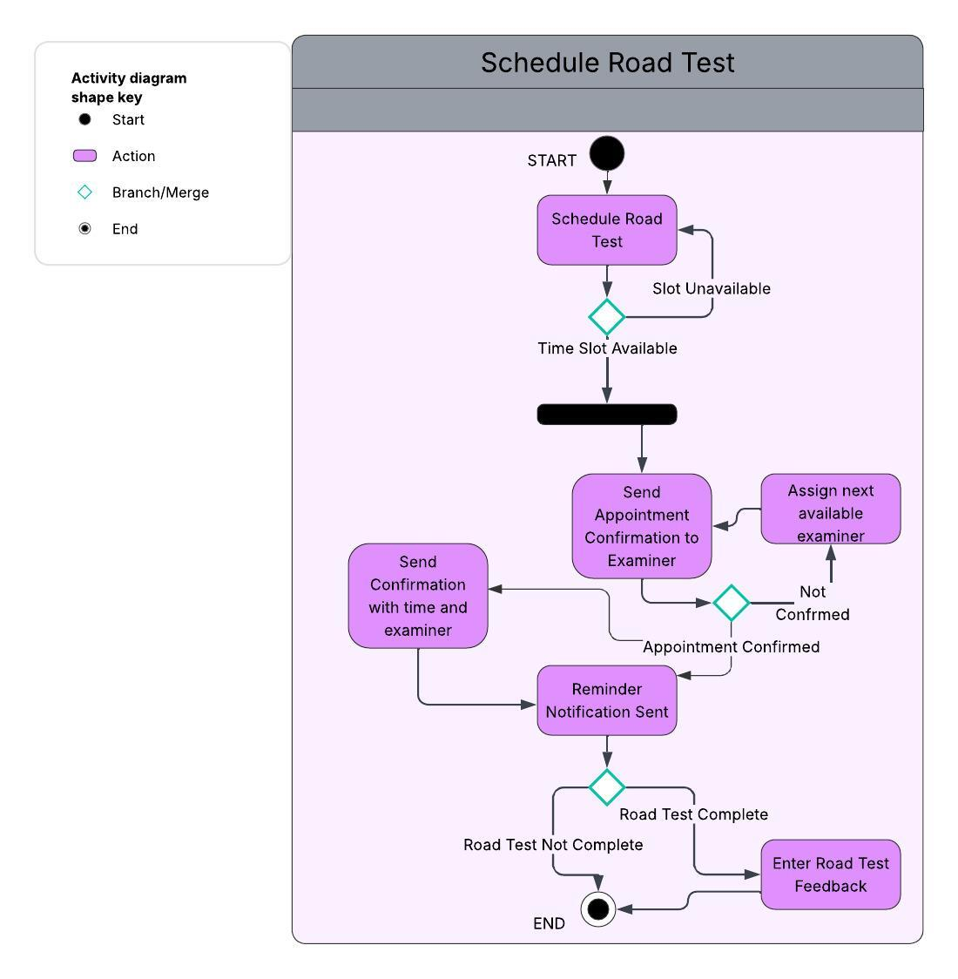

UML Sequence Diagram
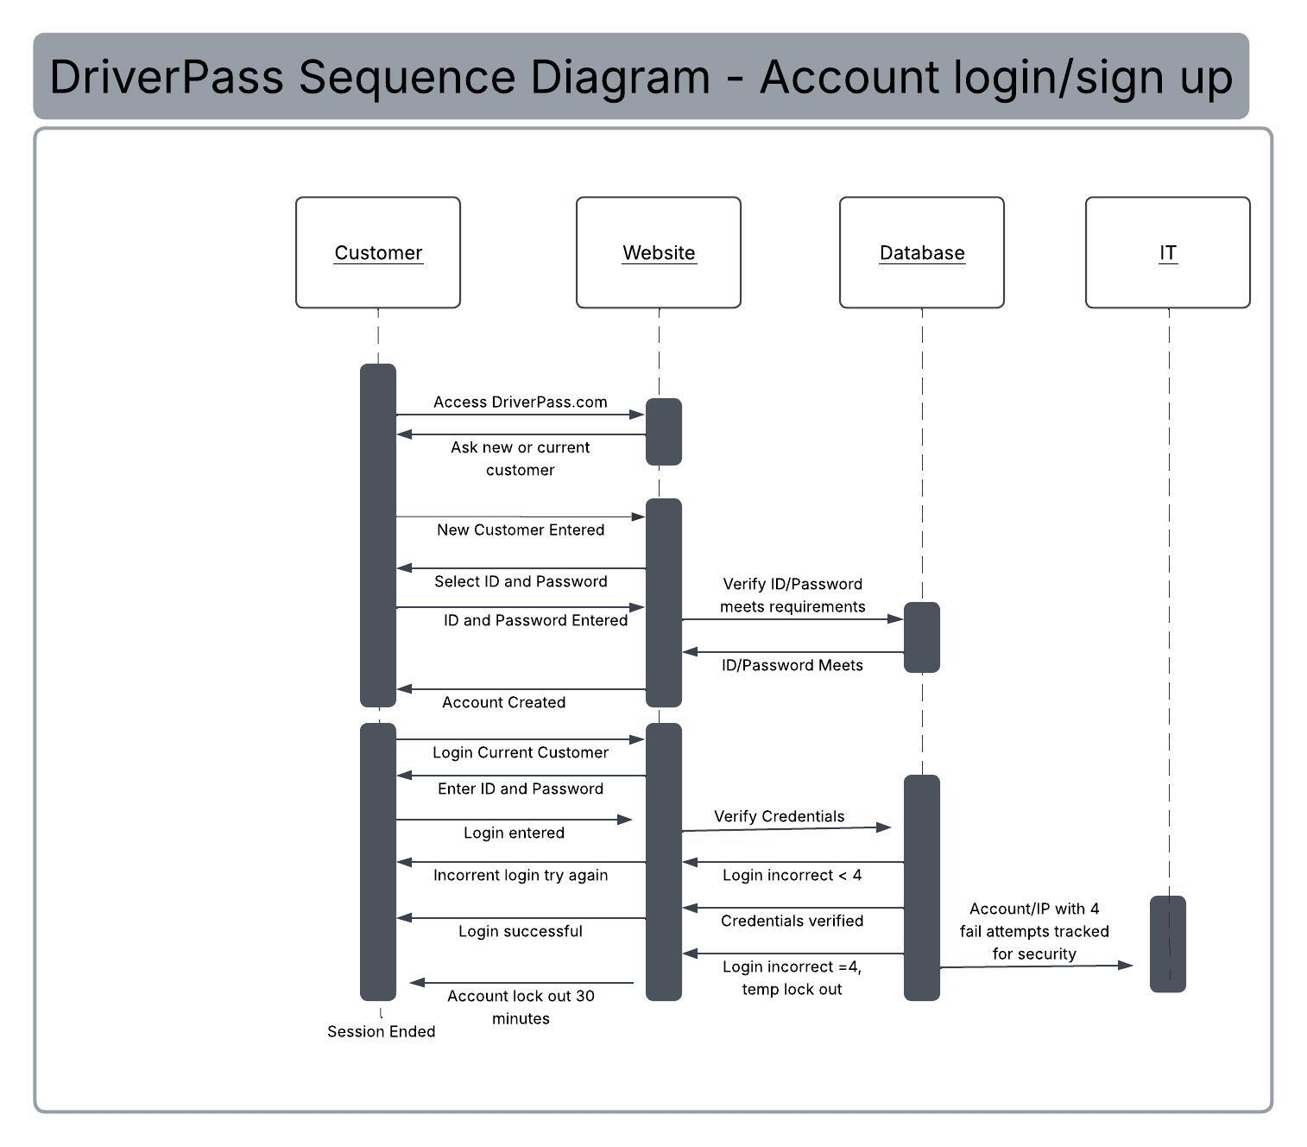

UML Class Diagram
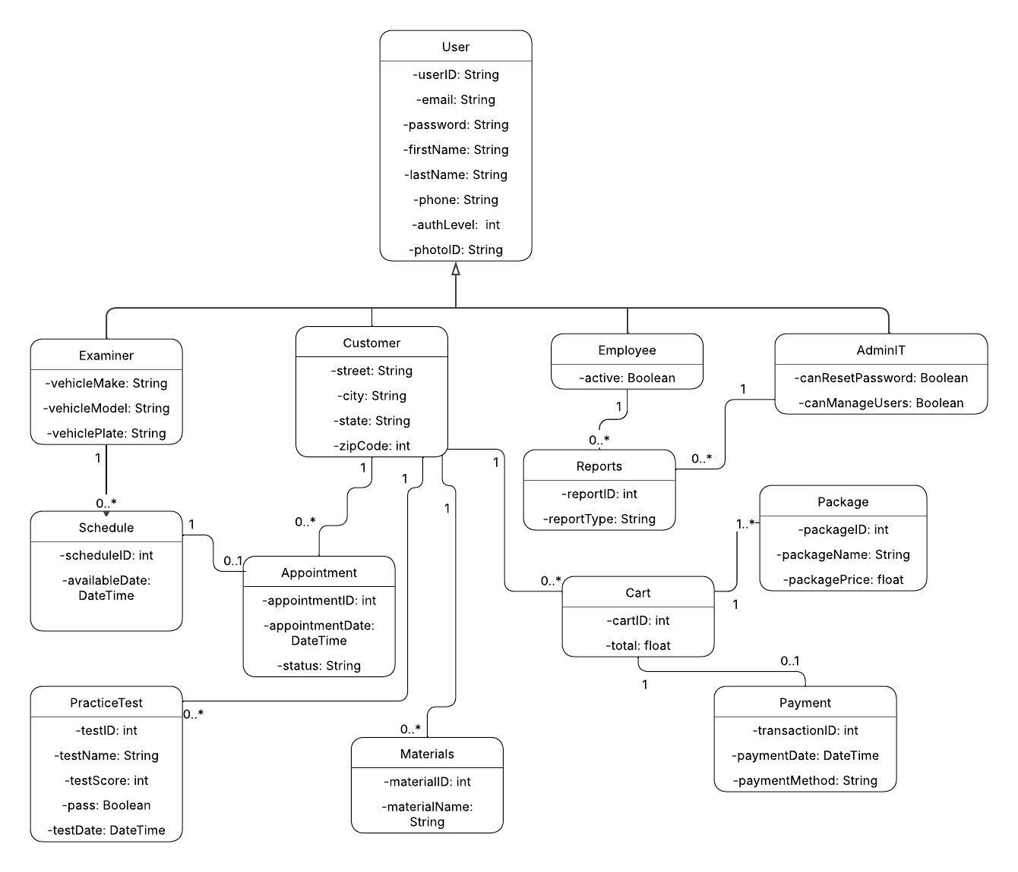

Technical Requirements

- Laptop or Desktop for each employee
- Cloud service to host DriverPass website and database
- High speed internet access
- Industry standard firewall protection
- Database management system
- Security Software
- Payment processing software
- Reporting tools
- Schedule management
- DMV materials and testing
- Automated backup and recovery
- Role-based access control
- Industry standard encryption

